**4. ReactJS-HOL**

**Post.js:**

class Post {

  constructor(userId, id, title, body) {

    this.userId = userId;

    this.id = id;

    this.title = title;

    this.body = body;

  }

}

export default Post;

**PostsList.js:**

import React, { Component } from 'react';

class Post extends Component {

  render() {

    return (

      <div>

        <h3>{this.props.title}</h3>

        <p>{this.props.body}</p>

        <hr />

      </div>

    );

  }

}

class PostsList extends Component {

  constructor(props) {

    super(props);

    this.state = {

      posts: [],

    };

  }

  loadPosts = () => {

    fetch('https://jsonplaceholder.typicode.com/posts')

      .then((res) => res.json())

      .then((data) => this.setState({ posts: data }))

      .catch((error) => {

        console.error('Error fetching posts:', error);

        alert('Error fetching posts');

      });

  };

  componentDidMount() {

    this.loadPosts();

  }

  componentDidCatch(error, info) {

    alert('An error occurred: ' + error);

  }

  render() {

    return (

      <div>

        <h2>Posts List</h2>

        {this.state.posts.map((post) => (

          <Post key={post.id} title={post.title} body={post.body} />

        ))}

      </div>

    );

  }

}

export default PostsList;

**index.js:**

import React from 'react';

import ReactDOM from 'react-dom/client';

import App from './App';

const root = ReactDOM.createRoot(document.getElementById('root'));

root.render(

  <React.StrictMode>

    <App />

  </React.StrictMode>

);

**App.js:**

import React from 'react';

import PostsList from './PostsList';

function App() {

return (

<div>

<PostsList />

</div>

);

}

export default App;

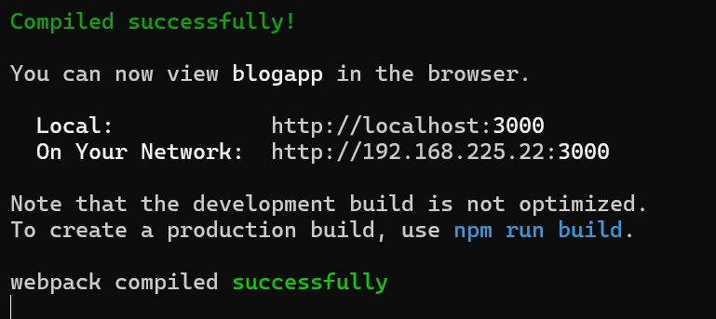

**Output:**

